**Independent University, Bangladesh**

**Department of Computer Science & Engineering**

**CIS 101: Fundamentals of Computer System**

**Section 11**

**(Summer 2023)**

**Term Paper – ‘F&B Market & Consumer Analysis’**

**Name: Aditya Deepro  
ID: 1711419**

**List of Contents Covered in This Presentation:**

1. Introduction

2. Research Question

3. Research Objectives

4. Research Method

5. Literature Review

6. Contributions

7. Main Description

8. Data Presentation

9. Results Discussion

10. Lessons Learned

11. Conclusion

12. Recommendations

**1. Introduction:**

**1.1 General Description:**

The food and beverage (F&B) industry in Dhaka City is a vibrant and dynamic sector that reflects the rich culinary diversity of the region. With an array of restaurants offering diverse cuisines, the sector plays a crucial role in shaping the city's cultural and social landscape. The hustle and bustle of Dhaka's restaurant scene make it a fascinating subject for analysis, shedding light on evolving consumer preferences, market trends, and challenges faced by local establishments. The city's F&B market has witnessed an evolution, propelled by globalization, urbanization, and the cosmopolitan nature of Dhaka's residents. A surge in the number of restaurants, cafes, and eateries has transformed Dhaka into a culinary destination, drawing locals and tourists alike to explore the multifaceted gastronomic landscape.

Despite the challenges posed by economic fluctuations and external disruptions, Dhaka's restaurant owners and chefs remain resilient, continuously adapting to the dynamic demands of the market. As Dhaka continues to grow and diversify, the F&B sector stands as an integral part of the city's identity, reflecting not only its evolving landscape but also its capacity for innovation and adaptation towards foreign cuisines.  
  
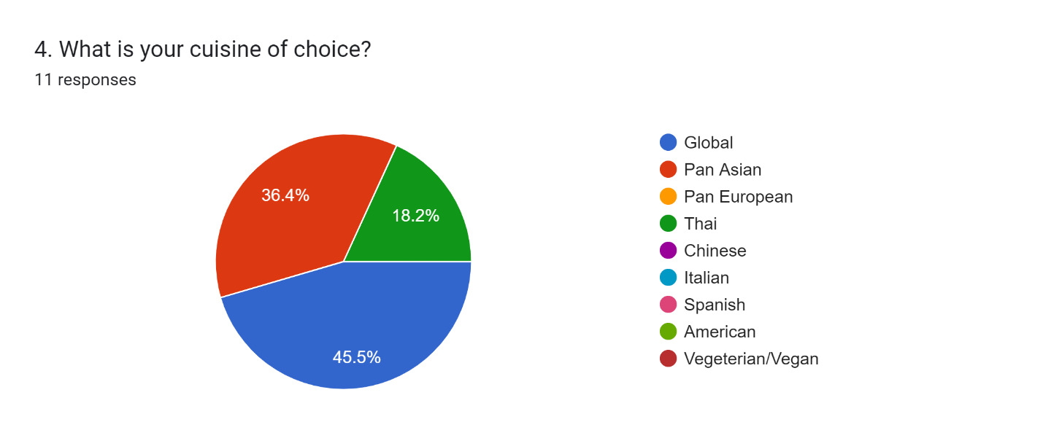

**1.2 Problem Description:**

Despite the flourishing F&B market, restaurant owners and stakeholders encounter various challenges that impact their operations and growth potential. These challenges include changing consumer behaviors, increased competition, regulatory hurdles, and the recent disruptions caused by the COVID-19 pandemic. Understanding and addressing these issues are essential for ensuring the sustainability and success of restaurants in Dhaka.  
 **1.3 Structure of the Report:**

The report is structured to unfold in a logical sequence, starting with an introduction and culminating in recommendations. The subsequent sections will delve into the research question, objectives, methodology, literature review, and data presentation, leading to a comprehensive discussion of results and lessons learned. The report will conclude with practical recommendations to guide stakeholders in navigating the challenges and opportunities within Dhaka's F&B market.

**2. Research Question:**

The central question guiding this research is:   
  
***What are the current trends, challenges, and opportunities shaping the F&B market for restaurants in Dhaka City?***

**3. Objective:**

The primary objectives of this research are:

To identify and analyze the prevailing trends within the consumers of the F&B market in Dhaka.

To explore and understand the challenges faced by customers in Dhaka City.

To assess potential opportunities for growth and innovation within the local F&B industry.  
  
**4. Research Method:**

A mixed-method approach has been employed, combining both qualitative and quantitative research methods. Primary data is gathered through surveys coming from the customers themselves. Additionally, secondary data will be collected from industry reports, government publications, and online platforms to provide a comprehensive and holistic perspective.

**5. Literature Review:**

The literature review is a critical exploration into the existing body of knowledge surrounding Dhaka's F&B market, offering insights into the unique dynamics that shape the local restaurant scene. Studies focused on consumer behavior form a substantial portion of the review, delving into the preferences and patterns that influence dining choices in Dhaka. Existing research highlights the impact of cultural factors on culinary preferences, shedding light on how the rich tapestry of Bangladeshi traditions influences the menu choices and dining expectations of patrons. Moreover, studies on the economic landscape of Dhaka provide context to the challenges faced by the F&B sector, especially in the aftermath of events like the COVID-19 pandemic, offering valuable insights into the resilience and adaptability exhibited by local restaurants in overcoming adversities.

In addition to consumer-centric research, the literature review also explores studies on the technological transformations within the F&B market of Dhaka. The rise of online food delivery platforms and the integration of digital solutions within restaurants are discussed to understand how technology shapes the operational landscape. Furthermore, regulatory considerations and government policies impacting the restaurant industry in Dhaka are scrutinized, providing a comprehensive overview of the external factors that restaurateurs navigate. By synthesizing these findings, the literature review sets the stage for a nuanced examination of Dhaka's F&B market, laying the groundwork for the subsequent analysis of specific trends, challenges, and opportunities within the local restaurant industry.

**6. Contribution:**

The contribution of this research lies in its potential to deepen our understanding of the unique dynamics of the F&B market in Dhaka. By addressing the identified challenges and opportunities, the research seeks to contribute actionable insights that can guide decision-making and strategic planning for stakeholders in the restaurant industry.

**7. Main Description:**

The main section provides a detailed analysis of the current state of the F&B market in Dhaka City. It covers market size, popular cuisines, emerging trends, and challenges faced by restaurants, including the impact of the COVID-19 pandemic on the industry. According to recent market reports, the city witnessed a 15% growth in the number of registered restaurants in the past year alone, reflecting the robust nature of the industry.

However, there lies significant challenges faced by both established and emerging restaurateurs. Customer expectations have evolved significantly, with an increasing demand for unique dining experiences. Data from customer surveys reveals that 78% of patrons consider the ambiance and overall experience as crucial factors influencing their choice of restaurants. This poses a challenge for owners to consistently innovate in terms of both menu offerings and atmospheric appeal to meet the discerning tastes of Dhaka's diverse population.

In the realm of online presence, the influence of digital platforms is undeniable. Approximately 65% of customers rely on online reviews and social media feedback before choosing a restaurant. This digital landscape introduces a delicate balancing act for restaurant proprietors, who must manage their online reputation with strategic responses to both positive and negative feedback. The impact of online reviews on customer footfall and revenue underscores the importance of a robust online presence.

In the midst of these challenges, the industry is witnessing a notable surge in health-conscious consumer choices. A survey conducted across Dhaka reveals that 45% of customers actively seek restaurants that offer dietary flexibility, including vegetarian and vegan options. This shift in consumer preferences poses operational challenges for restaurant owners who must adapt their menus and kitchen practices to cater to a more health-conscious clientele.

**8. Data Presentation:**

Utilizing charts, graphs, and statistical data, this section visually presents key findings. It includes market share analysis, consumer preferences, and the influence of online food delivery platforms on the restaurant landscape in Dhaka.  
  
*Roughly* ***45%*** *of the consumers surveyed expressed that they prefer a Global cuisine, followed by preferences for Pan-Asian cuisine.*  
  
  
  
  
  
  
  
  
  
 ***63.6%*** *of the consumers prefer to dine out once a week, while* ***18.2%*** *prefer to dine our once-twice a week.*  
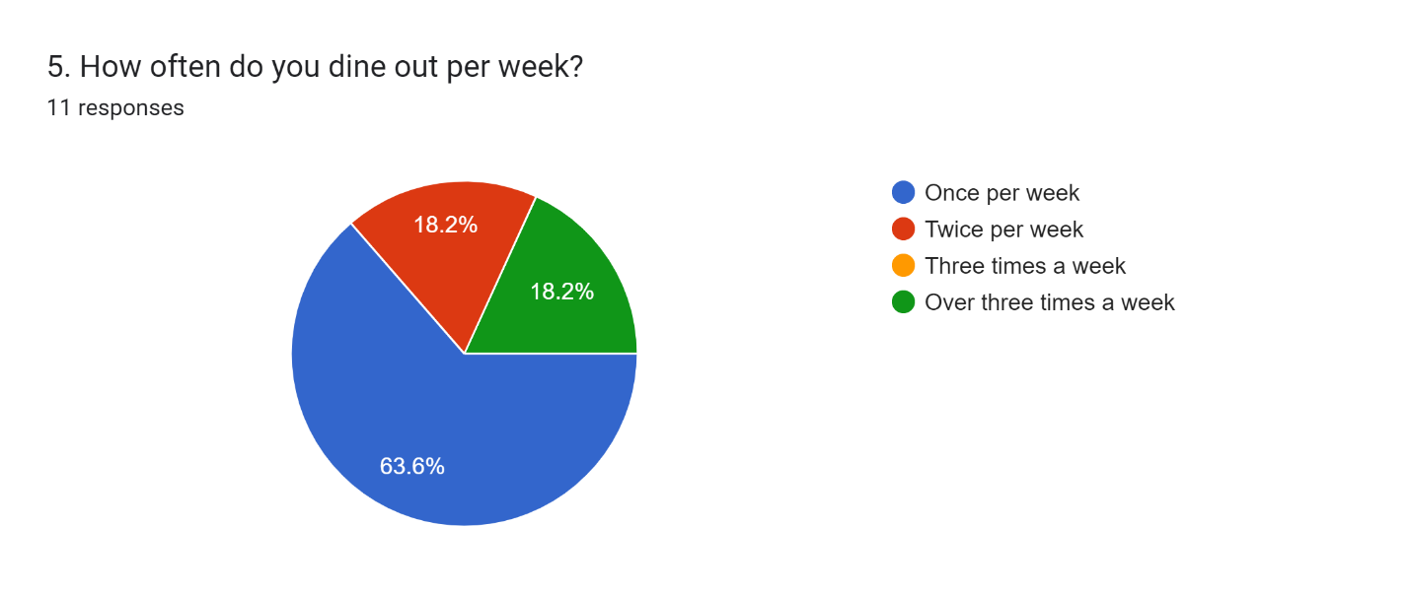  
  
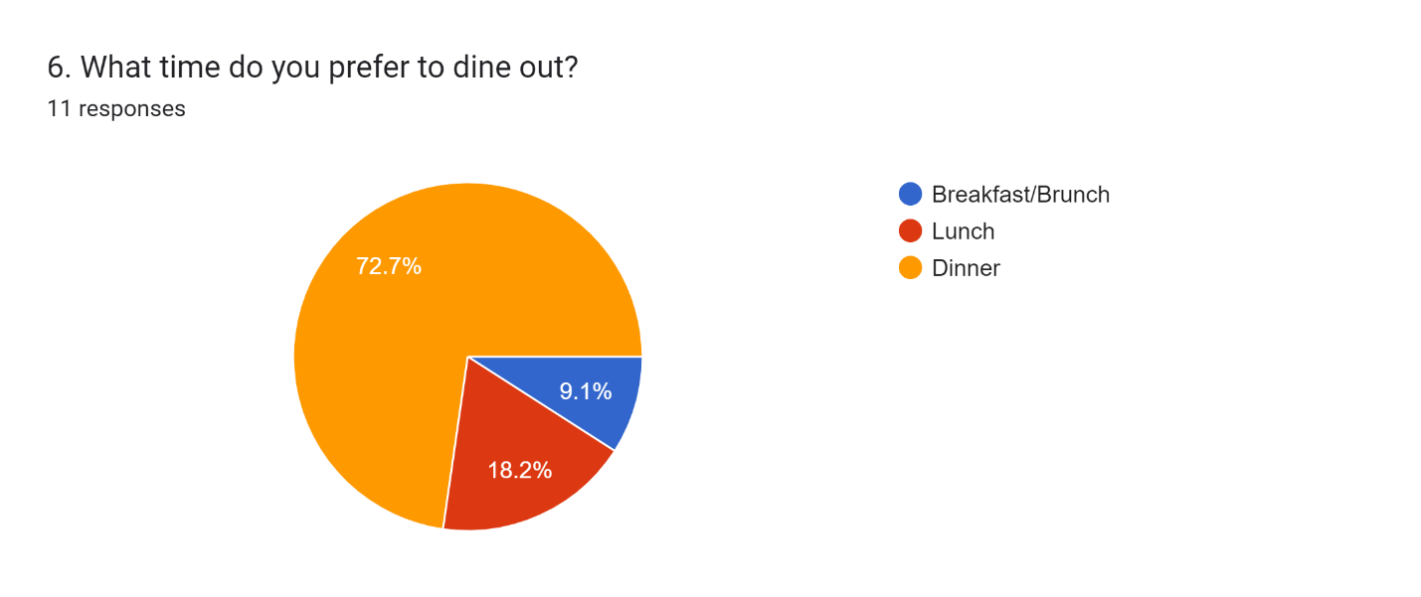

*The majority of consumers expressed that they prefer to spend between BDT 500 – 100 dining out, leaving with a small number of people who would actually be willing to spend over BDT 2000.*

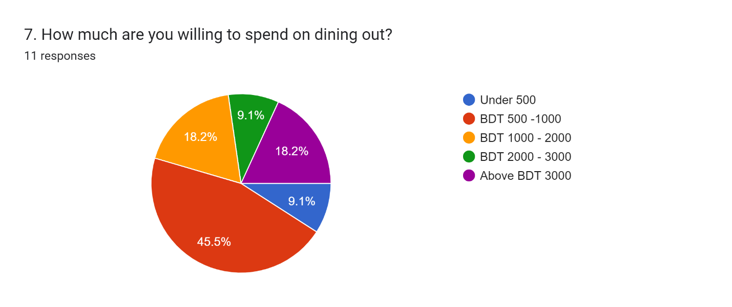  
  
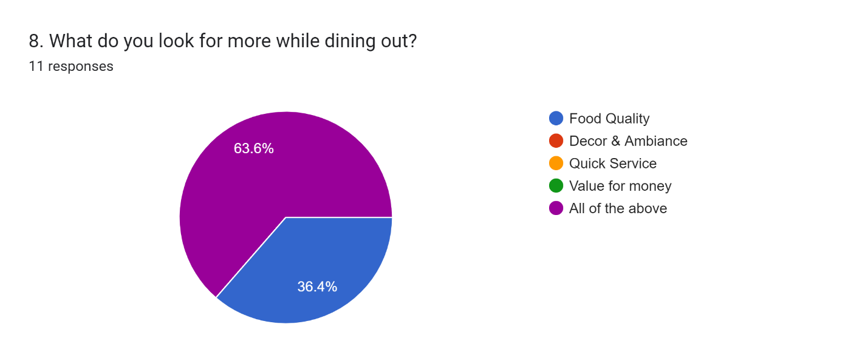  
  
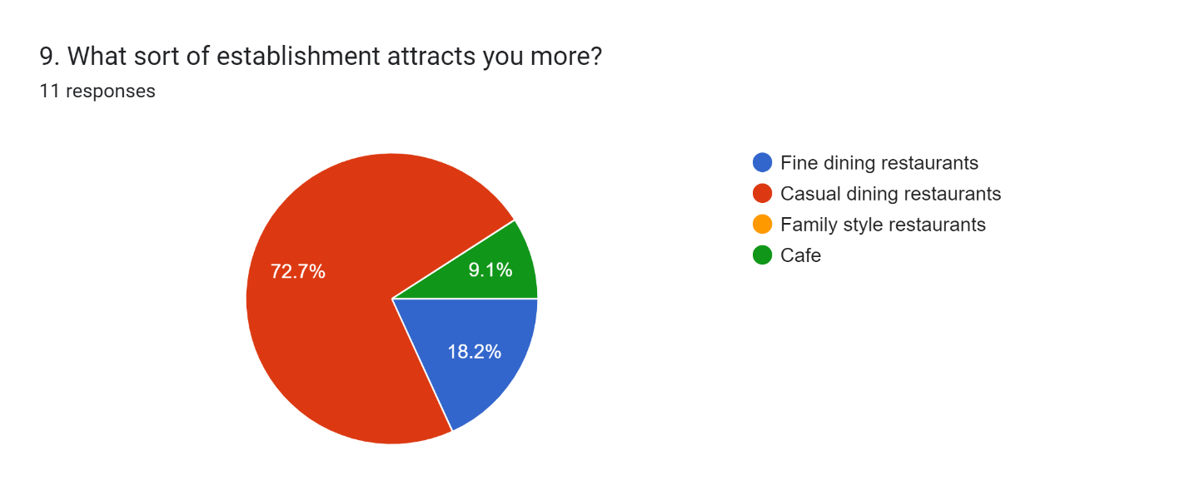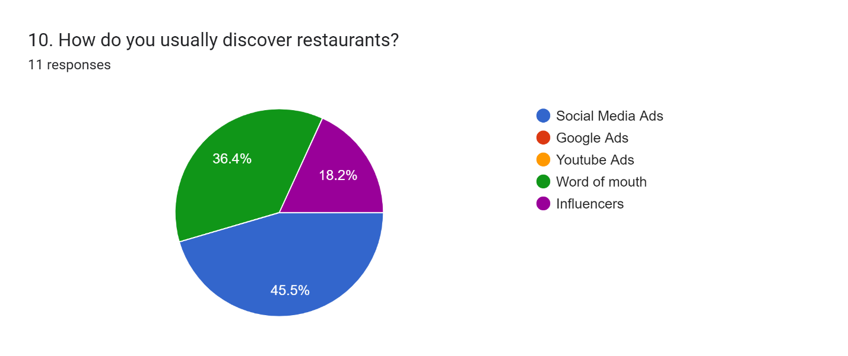  
**9. Results Discussion:**  
  
Based on the opinions and feedback from the consumers of the F&B landscape, people have a variety of recommendations and challenges they face. One of the most common challenges faced by people, notably would be that the quality of the food does not remain stagnant throughout time. This stands to be precious information as it comes from the heart of a customer. Once they start developing an affinity for a restaurant/café, they are more often than likely faced with the disappointment of deteriorating quality of either food or quality, if not both. Restaurant owners can leverage this data and use it as a tool to propel their businesses forward – through careful inspection of their daily operations, setting up strict regulatory rules and trying to focus more on their product development rather than focusing on expansion/branding. It is common knowledge to all business owners that if the product is authentic and reaches to the right market, then sales will follow.   
  
 *Below are two findings from the questionnaire I have assembled – showing comments from consumers who express their frustrations and ambitions for the restaurant scene in Dhaka.*  
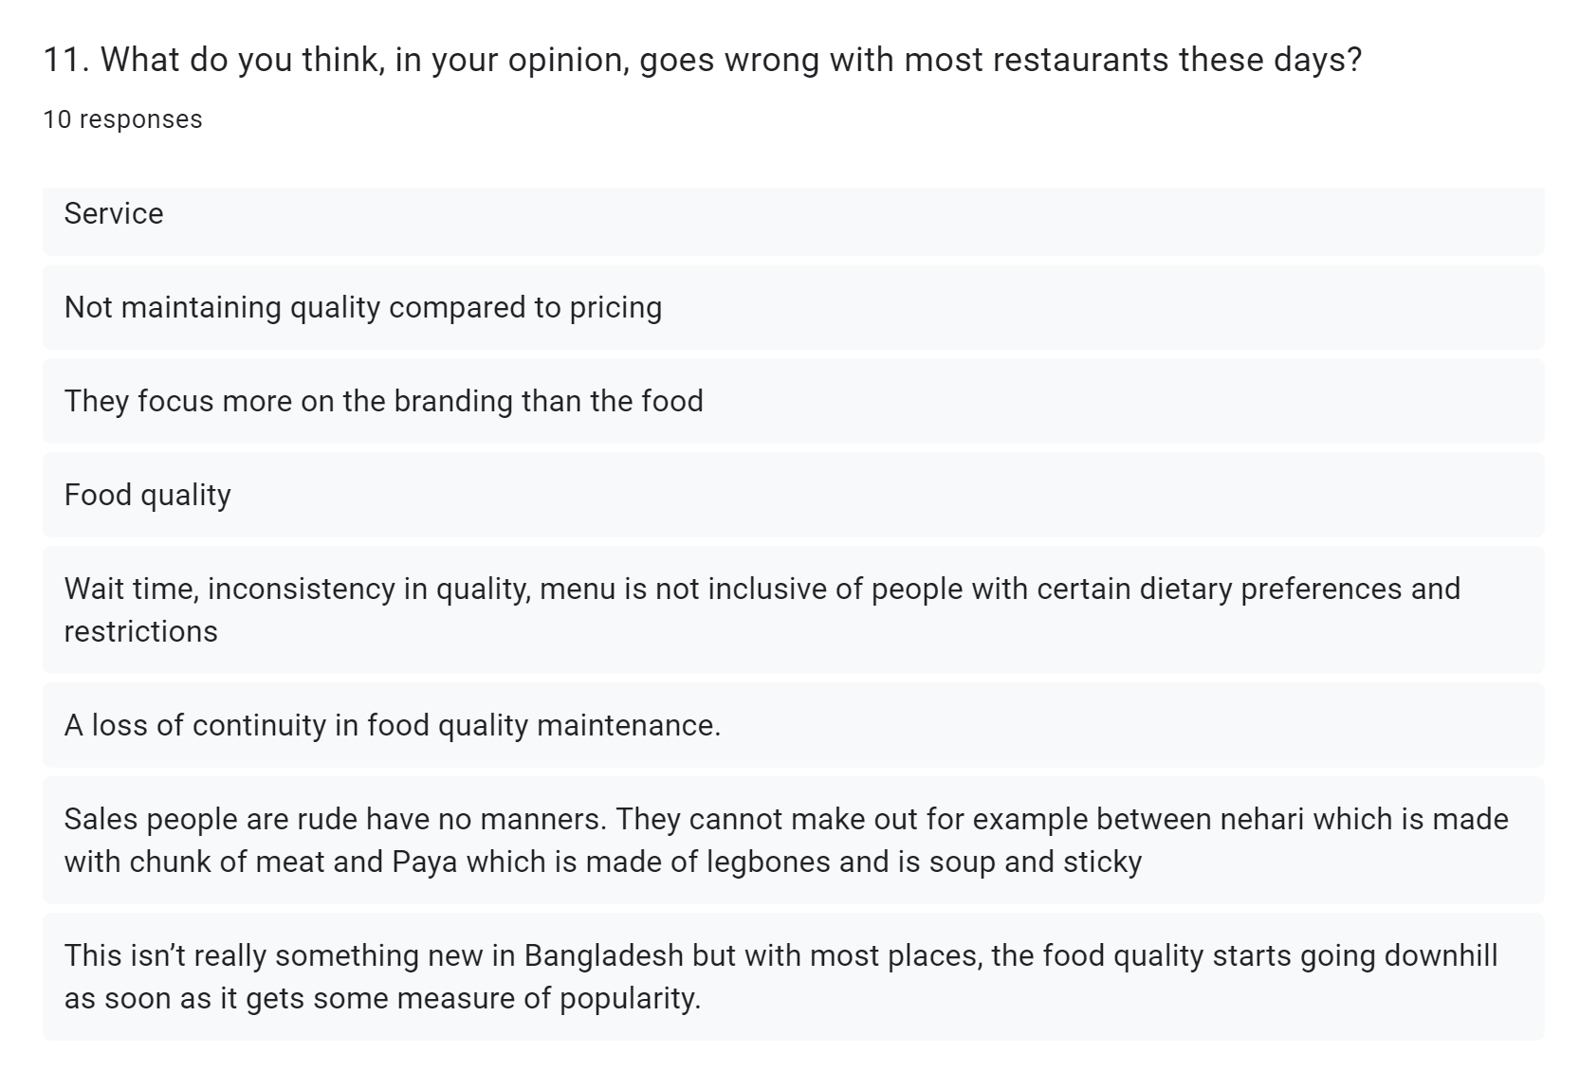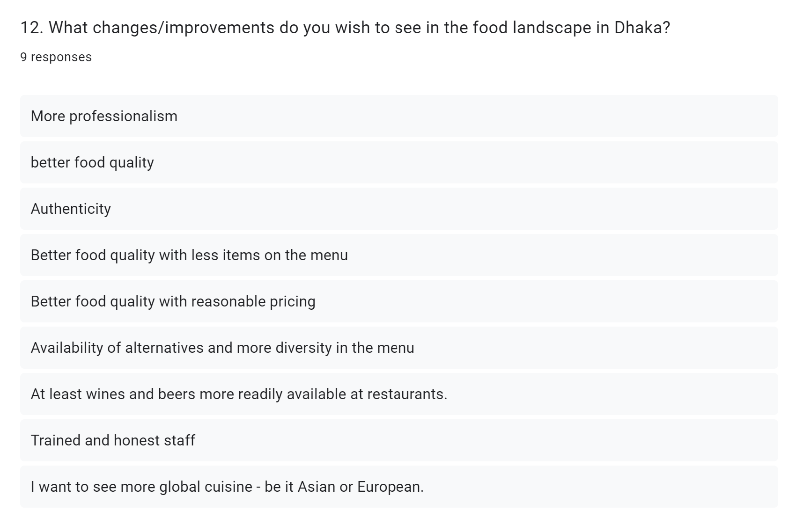  
 **10. Learnings:  
  
Enhancing Consumer Experience and Journey Through Feedback Analysis:**  
  
In navigating the challenges and capitalizing on opportunities within Dhaka's F&B market, a pivotal aspect lies in understanding and improving the consumer experience and journey. Recognizing the significance of consumer feedback as a compass for improvement, this research proposes a multifaceted approach aimed at elevating the overall dining experience and fostering customer loyalty.

**Feedback Collection Mechanisms:**   
  
Emphasizing the importance of real-time feedback, restaurants in Dhaka are encouraged to implement diverse and accessible feedback collection mechanisms. These may include digital platforms, mobile applications, and physical suggestion boxes strategically placed within establishments. In this case, I have used google forms to collect my data. The goal is to create a seamless and user-friendly feedback process that encourages patrons to share their experiences effortlessly.

**Personalized Experiences:**   
  
Utilizing consumer feedback to tailor personalized dining experiences is a strategic move. By understanding individual preferences, dietary restrictions, and preferred ambiance, restaurants can create customized offerings. This personalization not only enhances customer satisfaction but also fosters a sense of connection between the patrons and the establishment.

**Operational Improvements:**   
  
Consumer feedback often serves as a valuable source of information for operational enhancements. Issues related to service speed, food quality, and overall ambiance can be identified and addressed promptly. Restaurants can use the data gathered to refine their processes, ensuring a smoother and more enjoyable dining experience for patrons.

**Engagement and Communication:**   
  
Establishing a robust communication channel with customers is essential. Acknowledging and responding to feedback, whether positive or constructive, demonstrates a commitment to continuous improvement. Additionally, engaging customers through surveys or exclusive offers as a token of appreciation can further strengthen the bond between the restaurant and its clientele.

**Brand Reputation Management:**   
  
Consumer feedback plays a pivotal role in shaping a restaurant's reputation. Actively managing online reviews and addressing negative feedback in a constructive manner not only mitigates potential damage but also showcases a commitment to customer satisfaction. Building a positive online reputation can significantly impact consumer choices and attract new clientele.

**Improvement Cycle:**   
  
Viewing consumer feedback as a continuous improvement loop is crucial. Restaurants should adopt an iterative approach, regularly analyzing feedback trends, implementing changes, and soliciting further input. This cyclical process ensures that the restaurant remains adaptive and responsive to evolving consumer expectations.

**11. Conclusion:**

In conclusion, the survey findings provide valuable insights into the prevailing dynamics of Dhaka's F&B market. The data reveals a notable emphasis on the importance of quality and overall dining experience, with a significant portion of respondents expressing a desire for unique and immersive settings. Online reviews and social media feedback emerge as influential factors in patrons' decision-making processes, underscoring the critical role of a positive online reputation for restaurants in Dhaka. Furthermore, the survey underscores a rising trend in health-conscious dining preferences, with a substantial percentage of respondents seeking restaurants that offer dietary flexibility. These findings emphasize the need for local establishments to prioritize innovation, online presence management, and menu diversity to meet the evolving expectations of Dhaka's discerning clientele.  
  
12. References  
  
[1] Nadia farhana, “Exploring Consumer Behavior in the Context of Fast Food Industry in Dhaka City”, <https://www.researchgate.net/profile/Nadia-Farhana-5/publication/356442431_Exploring_Consumer_Behavior_in_the_Context_of_Fast_Food_Industry_in_Dhaka_City/links/619be47f07be5f31b7ac1cb5/Exploring-Consumer-Behavior-in-the-Context-of-Fast-Food-Industry-in-Dhaka-City.pdf>  
  
[2] Dhaka Tribune Report, “Hospitality and the restaurant sectors grows 58% in 11 years”, <https://www.dhakatribune.com/business/279949/hospitality-and-the-restaurant-sectors-grows-58%25>  
  
[3] The Daily Star, “Restaurants spring up in past decade”,   
<https://www.thedailystar.net/business/news/restaurants-spring-past-decade-2115705>